PUSD Parent Guide for Schoology
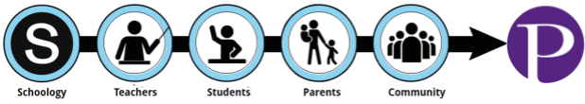
Schoology is PUSD’s Learning Management System. With Schoology, students may digitally submit homework assignments, participate in interactive discussions, receive announcements and feedback, take tests, write academic blogs, and more. Schoology brings together the digital elements of your child’s education into one location!
As a parent, you can use Schoology to:
- View your student’s courses
- View your student’s upcoming, current and overdue assignments
- Monitor school and course announcements
- Stay involved in your student’s education
- Monitor student grades and performance

Table of Contents

- Creating a Parent Account in Schoology
- Navigating the Parent Account in Schoology
  - School’s Announcement Page
  - Viewing Your Child's Activity
  - Viewing Recently Graded Assignments (may not be applicable for most elementary classes)
  - Viewing Courses
  - Upcoming Assignments in a Course
  - Viewing Course Materials
  - Viewing Current Grades (may not be applicable for most elementary classes)
  - View your Child’s Calendar
  - Update Account Settings
- Setting Up Notifications
Step 1: Creating a Parent Account in Schoology

Creating a Parent Account in Schoology
1. | If you have accessed a parent account in Schoology prior to this year, continue using the account as you always have.  Log in here. | 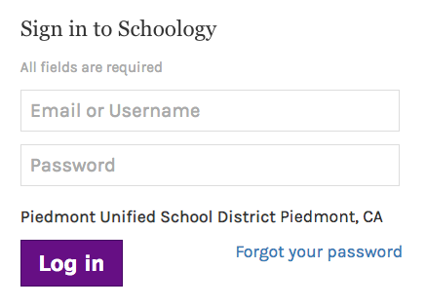
2. | If you have never previously accessed your Schoology parent account prior to this school year, you will receive an email early this school year with the subject, "Schoology Registration." This email will go to the email address you have listed in your Infinite Campus account, and will include your username and temporary password for Schoology.  If you have any problems logging in, or you can’t find the email, please contact one of the following members of our Technology Team::  Piedmont Middle School, Wildwood, Beach, & Havens:  Adam Saville asaville@piedmont.k12.ca.us  Piedmont and Millennium High Schools:  Debbi Hill dhill@piedmont.k12.ca.us | 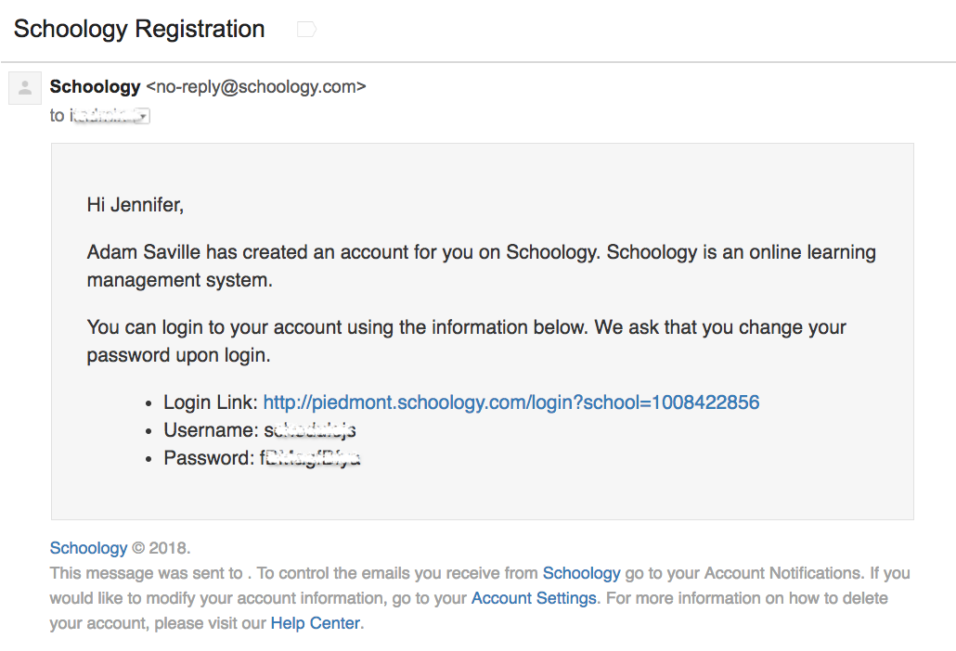

Step 2: Navigating Schoology & Updating Your Preferences

Navigating the Parent Account in Schoology
a. | School’s Announcement Page:  When the parent’s name is displayed, you are on the parent main page, which currently does not contain much information, but may soon include school announcements.  Having a Parent account in Schoology is actually like having two accounts:  - Your personal account, with your own name and information;  - Your Child Activity view. From here, you can view Schoology from your child’s perspective, and see what he or she sees, and receive updates about his or her activity.  Start by clicking on the arrow in the upper-right corner, next to your name, and then select your child’s name to switch into his or her account. The check mark in this drop-down menu indicates which account you are currently viewing. | 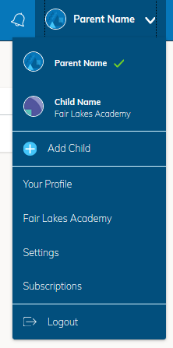
b. | Viewing Your Child’s Activity  Click on the arrow in the upper-right corner of your account and select your child’s name to view his or her activity.  From the home page, you can quickly view specific information about your child’s Schoology activity: | 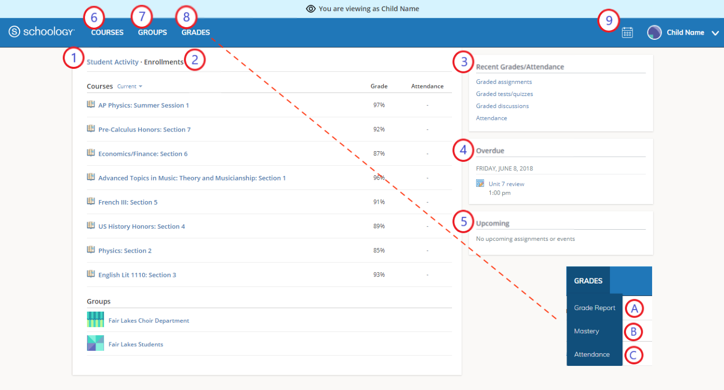
c. | *Viewing Recently Graded Assignments:  The top right column contains “Recent Grades.” Below Recent Grades, click on any of the graded categories for more information on materials graded within Schoology.  *May not be applicable for most elementary classes | 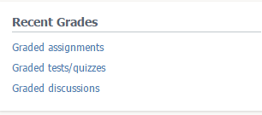
d. | Viewing Courses:  Click on the”Courses”on the top bar and select a course you’d like to see on the Courses page.  If you don’t see the courses, then you may need to logout and log back in. | 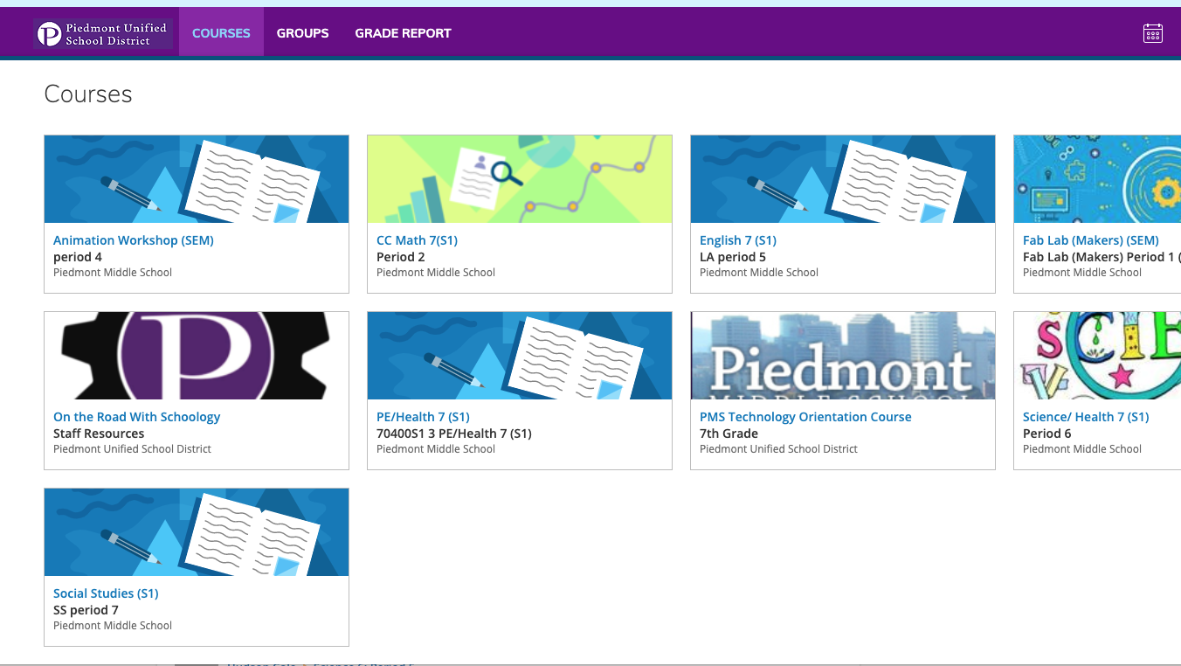
e. | Upcoming Assignments in a Course:  While in a course you can see upcoming assignments/assessments listed on the calendar on the right side of the window. If you click on the assignment you will get more information.  There is another calendar view available when clicking on Home at the top and then Calendar on the left side of the window. | 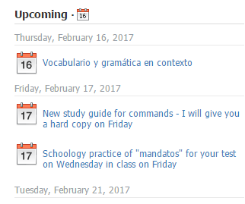
f. | Viewing Course Materials:  In the Course view, you can see course materials, including graded Schoology assignments. You can also see any posted updates and email an instructor. | 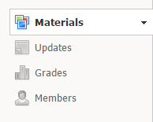
g. | **View Current Grades:  To view your child’s current grades, click on “Grade Report” on the top bar, and select the class for which you’d like to see grades.  Note:  You may see a score, or any of the symbols to the right, indicating excused, incomplete, or missing. You may also see a simple line “--” which indicates that the assignment’s due date has not yet arrived, and/or the assignment has not yet been graded.  **Elementary classes may not be using the Grade Report feature in Schoology | 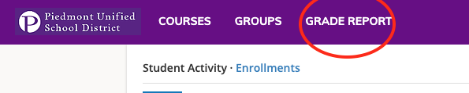  _________________________________  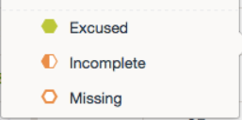
h. | View Your Child’s Calendar:  Click the calendar icon at the top right to view a calendar of past and upcoming events and assignments. To find out more information regarding a particular event, place your cursor over the title. A clue tip displays with the event type (assignment, test/quiz, event), and the event's course. Click the event to display profile information in a pop-up window. | 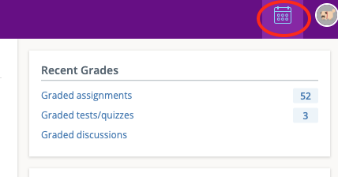
i. | Update Account Settings:  Updating account settings and account notifications can be found in the drop down menu on the right side of the screen. Find “Settings” at the bottom of the list. | 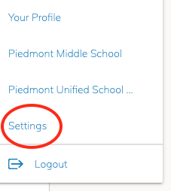

Step 3: Setting Up Notifications
You may elect to receive two email digests of your child(ren)'s activity in Schoology. To manage email digest settings in your parent account:

- Click the arrow on the top right of Schoology.
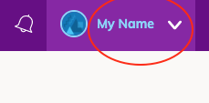

- Select a child from the list that appears in the drop-down menu.
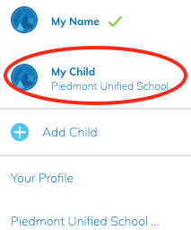

- Once you're viewing the child's account, click the downfacing arrow again.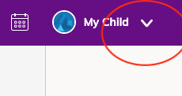

- Select Settings.

- From the Notifications tab, you can elect to receive one or both of two email summaries:
- To receive the Parent Email Digest, select On in your Email Summary menu.
You can receive emails on a Daily or Weekly basis. If you choose Daily, you may set a time at which the notification will be sent to your inbox. If you choose Weekly, you'll have an additional option to select the day of the week you'd like to receive the email.
Note: If there are no updates for the given time period, you will receive an email stating that there are no new updates.
- To receive the Overdue Submissions Email, select On in the Email Notification menu.
- Click Save Changes to update your settings.

What Do the Emails Look Like?
The Parent Email Digest contains:
- The date range for which information is displayed.
- Each of your children's names at the top of the email summary.
- A summary of each course for the child, including:
  - The child's current grading period grade for each course.
- Overdue Submissions, including:
  - How many days the item is past due.
  - The assignment, test/quiz, or discussion title.
  - The course in which the item is due.
Note: Overdue items marked as Excused or Missing are not included in Overdue Submissions.
- Recent activity, including:
  - The student's posts and updates in courses, assignments, tests/quizzes, and discussions.
  - Recent submissions for assignments and tests/quizzes.
- The digest includes up to five Summary items and up to ten Recent Activity items. To view more items than appears in the list, click the More option at the bottom of each area. If you have more than one child association, scroll down to view the Summary and Recent Activity for additional children.
- You will receive one Overdue Notification email for each time that your child fails to submit an item on time. You receive only one notification per late material regardless of how long it remains unsubmitted

How do I make sure I receive emails?
To make sure you receive emails, check that your email address is verified to receive emails from Schoology.
- Click the arrow on the top right of Schoology.
- Select your account from the list that appears in the dropdown.
- Once you're in your account, click the arrow again and select Account Settings.
- If you haven't yet verified your primary email address, you'll see a message to Resend verification email. Check the box next to the message and Save Changes.
- Once you receive the verification email, click the link provided in the email to verify your email address.
Note: If you don't receive the email at the correct time of day, check the timezone associated with your account from your Account Settings. If you don't receive any email notifications on a daily or weekly basis after having completed these steps, you can create a ticket with the Support Team for assistance.
